National Lawyers Guild

2022 Haywood Burns Memorial Fellowships
for Social and Economic Justice

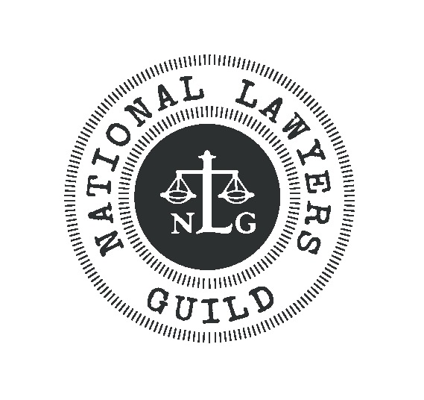

APPLICATION PACKET
Application Guidelines

HISTORY OF FELLOWSHIP
The Haywood Burns Memorial Fellowship for Social and Economic Justice has its roots in the National Lawyers Guild’s tradition of providing legal, political and educational support to the important progressive movements of the day. In the summer of 1964, the Guild sent lawyers and law students to provide legal support for the emerging civil rights movement in what became known as the Mississippi Summer. In 1973, the Summer Projects Committee was officially formed. The committee sent students to assist with the defense of the Attica Brothers, to work with the growing farmworker initiatives in California, and to support Native American treaty rights in the Pacific Northwest.

Over the years, the Summer Projects program has expanded to place hundreds of fellows with public interest organizations working to protect and further the civil rights of oppressed individuals and communities in the United States. Although providing legal work under the direction of their attorney-organizers is still important, the primary mission of the Projects is to strengthen each fellow’s long-term commitment to promote justice and equality. Fellows have worked with groups to provide legal, political, and educational support on a wide variety of issues, including housing rights; union democracy; workplace health and safety; the death penalty and prison reform; LGBTQ rights; defense of protesters from police harassment and criminal sanctions; and international human rights.

In 1996, the program was renamed after Haywood Burns, long-time radical lawyer, law professor and former NLG president, whose life and work created a legend to inspire generations to come. To learn more about Haywood Burns, visit www.nlg.org/fellowships.

ABOUT THE FELLOWSHIPS
The Haywood Burns Fellowships are designed to encourage work in the NLG tradition of “peoples’ lawyering.” The program helps students and legal workers apply their talents and skills to find creative ways to use the law to advance justice. Burns Fellowships challenge traditional notions of how one must practice law and provide a summer experience that will enrich and challenge fellows.

Fellowships may be completed with any existing organization whose mission addresses the needs of underserved individuals and groups. We encourage applicants to identify grassroots and non-traditional work opportunities for which there is a serious current societal need. This could be a small non-profit, a short-staffed community law firm, or an organizing campaign that needs legal assistance. The Haywood Burns Fellowships usually provide a rigorous legal experience as well as a political one. At the back of this brochure we list names of some of the former Haywood Burns placements to give applicants an idea of the work we have funded in the past.

The kinds of grassroots programs that are appealing to us have included developing legal trainings for animal rights and environmental activists, filing habeas petitions, assisting LGBTQ prisoners, conducting research designed to repeal the death penalty, and providing legal assistance to low-wage immigrant workers. We encourage applicants to pick timely projects that might be overlooked by more traditional sources of funding. We generally do not provide funding for work at large non-profits or agencies that receive government or corporate funding, or nonprofits that are able to provide their own funding to interns (such as the ACLU and the Center for Constitutional Rights). We do provide funding for both national and international projects.

In 2022, we expect to award $3,000 for ten weeks of full-time work (unless otherwise noted) and encourage fellows to pursue matching public interest grants or course credit to supplement this stipend. We will be considering both in person and remote internships.

A DIFFERENT FELLOWSHIP EXPERIENCE
One of the benefits of a Burns Fellowship is the mentorship and apprenticeship relationships that Fellows develop with NLG members locally, regionally, and nationally. Depending on the geographic location of the placements, we will introduce Fellows to Guild members working in their regions. Additionally, we provide free membership in the NLG for one year to all Fellows. As members of the Guild, Fellows are encouraged to join one or more of our many issue-related email lists, receive our organizational publications, and attend our annual convention at a discounted rate. Perhaps most important, membership in the Guild introduces fellows to a progressive community of lawyers, law students, legal workers, and jailhouse lawyers working in the service of the people. Guild lawyers are at the forefront of legal challenges related to civil rights, immigration law, environmental law, mass incarceration, national and international human rights and many other areas. The Guild is also a valuable forum for applying the tradition of “peoples’ lawyering” to meet present needs.

SELECTION CRITERIA AND EVALUATION
Projects will be evaluated on the basis of legal, political, and geographical diversity, as well as the project’s connections to the ongoing needs of the persons and communities served. Applications will be evaluated on the basis of the applicant’s and organization’s commitment to social justice and on a balancing of legal, practical and political work and skills development. Reviewers will also take into consideration the need for the project and how the experience will further the Fellow’s legal and career trajectory. Projects that produce a practical product or analysis that can be applied to the Guild’s work will be looked on favorably.

REQUIREMENTS OF FELLOWS
We expect to hear from our Fellows over their ten-week placement and encourage them to email us to let us know how their work is progressing or to ask us for help networking with other Guild members. In addition to their work during the ten weeks of the Fellowship, Fellows will also be asked to share their experiences with the broader Guild by submitting an article to Guild Notes, the NLG Blog, or NLG Review.

NLG MEMBERSHIP
Current NLG law student and legal worker members receive first priority in the selection process. If you are not already a member, you can join online at nlg.org/join. If you need a dues waiver, please email Traci Yoder at traci@nlg.org.

Application Instructions

INSTRUCTIONS:

1) Fill out the Application form below. Answer the questions in Part 2 in a separate document.

2) Include copy of current resume.

3) Submit a one- to two-page letter of support from the organization for which you would
like to work. The letter should include the following information:

1. Description of the legal work the Fellow will be responsible for
2. The need met by this Fellowship
3. Name of supervising attorney or legal worker who will have day-to-day contact
with the Fellow and extent to which someone can mentor the Fellow
4. Guarantee of all logistical needs (i.e. office spaces, supplies)
5. Amount of funding, if any, the sponsoring organization can provide

4) Email one complete application as a PDF to NLG Director of Education and Research Traci Yoder at traci@nlg.org.

Applications that arrive after the deadline or are incomplete upon arrival will not be considered. Please contact Traci Yoder at traci@nlg.org with any questions regarding the Fellowship or the application process.

THE DEADLINE FOR APPLICATIONS IS MONDAY, JANUARY 3, 2022.

APPLICANTS WILL BE NOTIFIED BY JANUARY 28, 2022.

Application Form

PART 1

Name: _______________________________________________________________________
Address: _____________________________________________________________________
City: ______________________________ State: ____________ Zip: ____________________
Phone: _______________________________ Email: __________________________________
Address and phone are valid until what date?____________
____Law Student Year:____________ Law School:_______________________________
____ Legal Worker Where:______________________________________________________
Optional Information (some may be for purposes of affirmative action):
Age:_________ Gender:___________ Under-represented Community:_____________________
Name of Project: _______________________________________________________________
Organization for which you plan to work:
_____________________________________________________________________________
Dates available to work: From________ To:________
Are you a member of the NLG? Yes____ No____ Which Chapter: ______________________
Have you participated in any NLG events, committees or projects? Yes____ No____
If so, which ones? ______________________________________________________________
Legal, political or educational organizations you are or have been active in: ________________
_____________________________________________________________________________

List the name, address and phone number of TWO references:
Reference 1:
Name: _________________________________ Address: _______________________________
City: ______________________________ State: ______________ Zip: ________________
Phone: ____________________________ Email:______________________________________
Reference 2:
Name: _________________________________ Address: _______________________________
City: ______________________________ State: ______________ Zip: ________________
Phone: ____________________________ Email: ____________________________________

PART 2- SHORT ESSAYS

Please answer the following essay questions clearly and concisely. Limit your answers to a total of three double-spaced pages.

A. REASONS FOR APPLYING: What are your reasons for applying? Describe your knowledge of the issues of concern to the projects that you have chosen.

B. EXPERIENCE: What kinds of legal, political, educational, and work experience do you have which are relevant and directly applicable to this Project?

C. GOALS AND PLANS: What do you expect to gain from this Fellowship? What types of legal and political work do you hope to do in the future? How do you see this internship helping you in your goals?

D. FOLLOW-UP WORK: How will you share your summer experience and skills with others? How can you carry the work of the project back to your community and/or law school?

E. GUILD PARTICIPATION: Please describe why you want to be part of the NLG. How you will share your fellowship experience with the organization?

Examples of Previous Placements
In previous years, law students have completed Burns Fellowships at dozens of agencies. Below are some of the sponsoring organizations where Fellows have worked.

- Advancement Project
- Alternatives for Community and Environment
- American-Arab Anti-Discrimination Committee
- American Immigration Council
- Appalachian Research and Defense Fund
- Asian Law Caucus
- Center on Race, Poverty & the Environment
- Civil Liberties Defense Center
- Center for Popular Democracy
- Communities Resist
- Disability Rights Advocates
- Equal Justice Initiative
- Farmworker Justice
- Florence Immigrant & Refugee Rights Project
- Georgia Resource Center
- Illinois Migrant Legal Assistance Project
- International Bridges to Justice
- Juvenile Justice Project of Louisiana
- Legal Services for Prisoners with Children
- Massachusetts Correctional Legal Services
- Midwest Environmental Advocates
- National Immigration Project of the NLG
- National Police Accountability Project of the NLG
- National Whistleblowers Center
- New York Lawyers for the Public Interest
- New Jersey Farmworker and Low Wage Worker Employment Rights Project
- Oregon Justice Resource Center
- Parole Preparation Project of the NLG
- People’s Law Office
- Project South
- Refugee Solidarity Network
- Springfield No One Leaves
- Sugar Law Center
- Sylvia Rivera Law Project

